**Lab 7 Assignment**

**Working with DOCKER**

**Aim:** Create three containers and access these containers from each other by using IP address and container name.

1. **Create three containers.**

Pull *busybox* Image

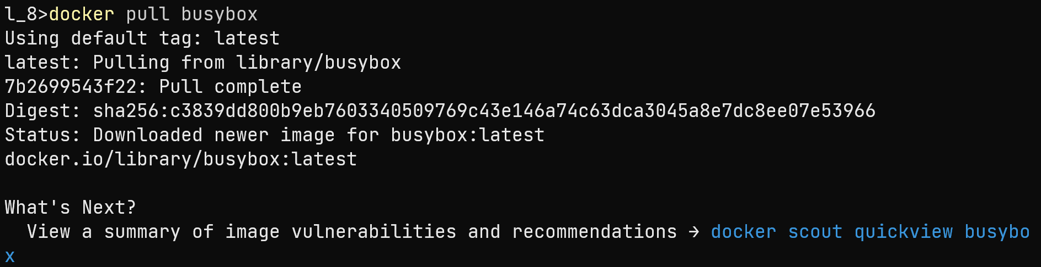

Create and run three containers

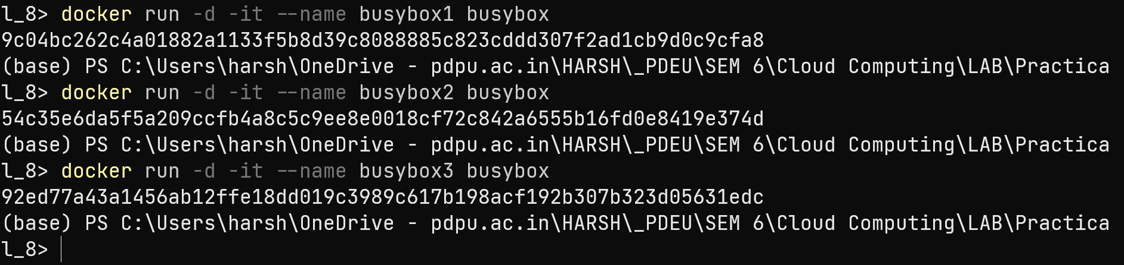

Create a network and connect with the containers



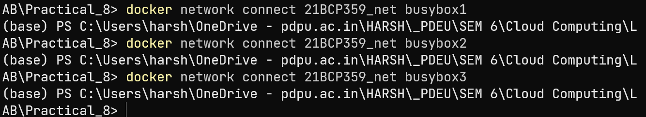

1. **Access these containers using IP address**

Find IP Address of containers







Ping from one container to another

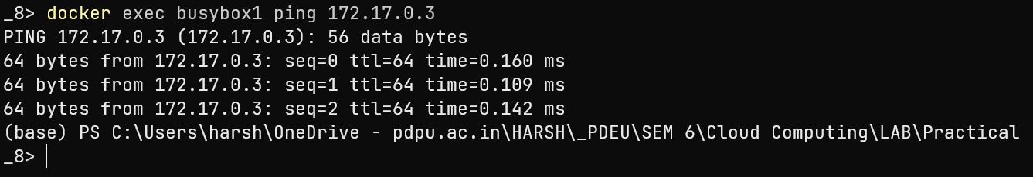

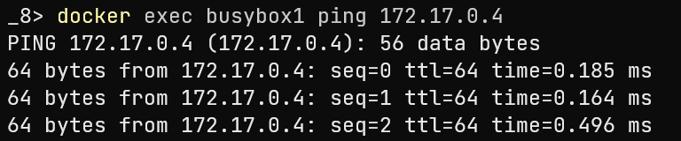

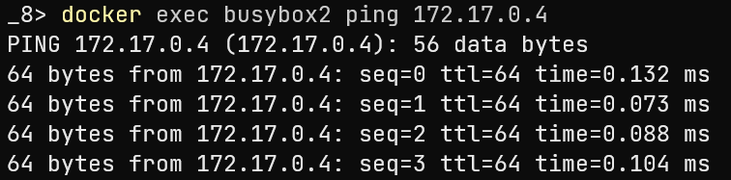

1. **Access these containers using container name.**

